REFLECTION RIDGE CHIROPRACTIC
WELCOME! Our goal is to help you achieve the best health possible. Please provide the following information as completely as you can. The better we communicate, the better we can care for your needs.
Patient Registration
Patient Name |  |  |  |  | How do you wish to be addressed? |  |  |  |  | Date of Birth
Address |  |  |  | City |  |  | State |  |  | Zip
Home Phone # |  | Cell Phone # |  |  |  |  | Social Security #
Email Address |  | Patient Status   Single  Married Other |  |  |  |  | School Status   Full-time  Part-time N/A
Account Information
 Patient’s Name  Guardian’s Name |  |  | Employer |  |  |  | Work Phone #
 Spouse’s Name  Guardian’s Name |  |  | Employer |  |  |  | Work Phone #
If the patient is a child, who is responsible for this account?

Is the condition we are treating related to a:  auto accident  work accident other accident N/A
PLEASE FILL OUT YOUR HEALTH INSURANCE INFORMATION BELOW. IF YOUR VISIT IS RELATED TO AN ACCIDENT, PLEASE PUT YOUR ACCIDENT INSURANCE INFORMATION ON THE ACCIDENTAL INJURY FORM.
Primary Health Insurance Information
Primary Insurance Company |  | Identification # |  |  |  |  | Name of Policyholder
Policyholder’s Social Security # |  | Policy/Group # |  |  |  | Policyholder’s Date of Birth |  |  | Insurance Phone #
Secondary Health Insurance Information
Secondary Insurance Company |  | Identification # |  |  |  |  | Name of Policyholder
Policyholder’s Social Security # |  | Policy/Group # |  |  |  | Policyholder’s Date of Birth |  | Insurance Phone #
How did you learn about our office? (If from a friend or relative, his/her name.) |  |  |  |  | Someone not living with you to contact in case of emergency (name and phone #).
Other family members in this practice:

Family Medical Doctor: | When doctors work together it benefits you. May we have your permission to update your medical doctor regarding your care at this office?  Yes  No
Patient's or Authorized Person's Signature: I authorize the release of any medical or other information necessary to process my insurance claim. I authorize payment of insurance benefits directly to the chiropractor or chiropractic office. I authorize the doctor to release all information necessary to communicate with personal physicians and other healthcare providers and payors and to secure the payment of benefits. I understand that I am responsible for all costs of chiropractic care, regardless of insurance coverage. I also understand that if I suspend or terminate my schedule of care as determined by my treating doctor, any fees for professional services will be immediately due and payable.

I hereby authorize the doctor to examine me and treat my condition as he or she deems appropriate through the use of chiropractic health care and I give authority for these procedures to be performed. The doctor will not be held accountable for any pre-medically diagnosed conditions nor for any medical diagnosis.

Signature: __________________________________________________________________________ Date:________________

PATIENT INTAKE FORM
Patient Name: _____________________________ Date: _______________

1. Is today's problem caused by: □ Auto Accident □ Workman's Compensation

2. Indicate on the drawings below where you have pain/symptoms
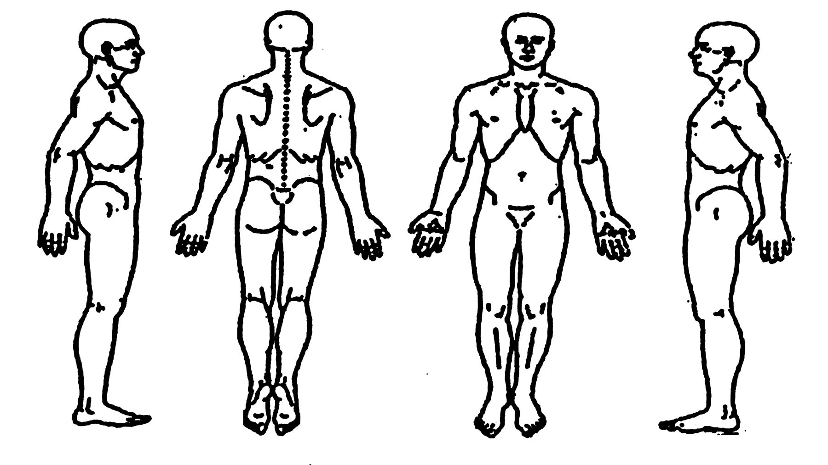
3. How often do you experience your symptoms?
□ Constantly (76-100% of the time) □ Occasionally (26-50% of the time)
□ Frequently (51-75% of the time) □ Intermittently (1-25% of the time)

4. How would you describe the type of pain?
□ Sharp □ Numb
□ Dull □ Tingly
□ Diffuse □ Sharp with motion
□ Achy □ Shooting with motion
□ Burning □ Stabbing with motion
□ Shooting □ Electric like with motion
□ Stiff □ Other:___________________

5. How are your symptoms changing with time?
□ Getting Worse □ Staying the Same □ Getting Better

6. Using a scale from 0-10 (10 being the worst), how would you rate your problem?
0 1 2 3 4 5 6 7 8 9 10 (Please circle)

7. How much has the problem interfered with your work?
□ Not at all □ A little bit □ Moderately □ Quite a bit □ Extremely

8. How much has the problem interfered with your social activities?
□ Not at all □ A little bit □ Moderately Quite a bit □ Extremely

9. Who else have you seen for your problem?
□ Chiropractor □ Neurologist □ Primary Care Physician
□ ER physician □ Orthopedist □ Other:_____________
□ Massage Therapist □ Physical Therapist □ No one

10. How long have you had this problem? ___________

11. How do you think your problem began?
___________________________________________________________________________________

12. Do you consider this problem to be severe?
□ Yes □ Yes, at times □ No

13. What aggravates your problem?
____________________________________________________________________________________

14. What concerns you the most about your problem; what does it prevent you from doing?
____________________________________________________________________________________

15. What is your: Height___________ Weight _____________ Date of Birth ___________
Occupation _____________________________________________________

16. How would you rate your overall Health? □ Excellent □ Very Good □ Good □ Fair □ Poor

17. What type of exercise do you do?
□ Stenuous □ Moderate □ Light □ None

18. Indicate if you have any immediate family members with any of the following:
□ Rheumatoid Arthritis □ Diabetes □ Lupus
□ Heart Problems □ Cancer □ ALS

19. For each of the conditions listed below, place a check in the "past" column if you have had the condition in the past. If you presently have a condition listed below, place a check in the "present" column.
Past Present Past Present Past Present
□ □ Headaches □ □ High Blood Pressure □ □ Diabetes
□ □ Neck Pain □ □ Heart Attack □ □ Excessive Thirst
□ □ Upper Back Pain □ □ Chest Pains □ □ Frequent Urination
□ □ Mid Back Pain □ □ Stroke □ □ Smoking/Tobacco Use
□ □ Low Back Pain □ □ Angina □ □ Drug/Alcohol Dependance
□ □ Shoulder Pain □ □ Kidney Stones □ □ Allergies
□ □ Elbow/Upper Arm Pain □ □ Kidney Disorders □ □ Depression
□ □ Wrist Pain □ □ Bladder Infection □ □ Systemic Lupus
□ □ Hand Pain □ □ Painful Urination □ □ Epilepsy
□ □ Hip Pain □ □ Loss of Bladder Control □ □ Dermatitis/Eczema/Rash
□ □ Upper Leg Pain □ □ Prostate Problems □ □ HIV/AIDS
□ □ Knee Pain □ □ Abnormal Weight Gain/Loss
□ □ Ankle/Foot Pain □ □ Loss of Appetite For Females Only
□ □ Jaw Pain □ □ Abdominal Pain □ □ Birth Control Pills
□ □ Joint Pain/Stiffness □ □ Ulcer □ □ Hormonal Replacement
□ □ Arthritis □ □ Hepatitis □ □ Pregnancy
□ □ Rheumatoid Arthritis □ □ Liver/Gall Bladder Disorder
□ □ Cancer □ □ General Fatigue
□ □ Tumor □ □ Muscular Incoordination
□ □ Asthma □ □ Visual Disturbances
□ □ Chronic Sinusitis □ □ Dizziness
□ □ Other:____________________________

20. List all prescription medications you are currently taking:
_______________________________________________________________________________

21. List all of the over-the-counter medications you are currently taking:
________________________________________________________________________________

22. List all surgical procedures you have had:
________________________________________________________________________________

23. What activities do you do at work?
□ Sit: □ Most of the day □ Half the day □ A little of the day
□ Stand: □ Most of the day □ Half the day □ A little of the day
□ Computer work: □ Most of the day □ Half the day □ A little of the day
□ On the phone: □ Most of the day □ Half of the day □ A little of the day

24. What activities do you do outside of work?
_________________________________________________________________________________

25. Have you ever been hospitalized? □ No □ Yes
if yes, why __________________________________________________________________________

26. Have you had significant past trauma? □ No □ Yes

27. Anything else pertinent to your visit today?______________________________________________

Patient Signature___________________________________ Date:____________________

X-RAY CONSENT

I hereby consent to allow x-rays to be taken of any affected areas designated by the doctor. I hereby, release Reflection Ridge Chiropractic from any liability resulting from this x-ray. I give my permission for any x-ray films to be reviewed by any member of this clinic with regard to my condition and for the purpose of treatment of my condition. I agree that my films may be released to another physician for review should the doctor feel this is in my best interest, but not to be released without my knowledge and consent.

SIGNATURE__________________________________________________________________

DATE___________________________________________

FEMALE PATIENTS:X-rays can cause damage to an unborn fetus. I hereby certify that I am not pregnant at this time and I give my permission for x-rays to be taken. If at a later date I find that I was pregnant without my knowledge, I will not hold Reflection Ridge Chiropractic liable.

SIGNATURE__________________________________________________________________

DATE___________________________________________

IF PATIENT IS A MINOR
I certify that I am the parent or legal guardian of this minor child (any child under the age of 18). I hereby give my permission for x-rays to be performed on this child. I also certify that this child, if female, is not pregnant to my knowledge and that if I find the child is pregnant without my knowledge, I will not hold Reflection Ridge Chiropractic liable for possible damage to the unborn fetus.

SIGNATURE__________________________________________________________________

DATE___________________________________________

WITNESS____________________________________________________________________

REFLECTION RIDGE CHIROPRACTIC DATE: _________________
2290 N. TYLER RD STE 100
WICHITA, KS 67205 NAME: ___________________________________

INFORMED CONSENT TO TREATMENT

I hereby request and consent to the performance of Chiropractic adjustments and other Chiropractic procedures, including various modes of physical therapy and diagnostic x-rays on me (or the patient named below, for whom I am legally responsible) by the Doctor of Chiropractic named below and/or other licensed Doctors of Chiropractic who now or in the future work at the clinic or office listed on this page.

I have/or will have the opportunity to discuss with the Doctor of Chiropractic named below and/or with other office or clinic personnel the nature and purpose of Chiropractic adjustments and other procedures. I understand that results are not guaranteed.

I understand and I am now informed that, as in the practice of medicine, in the practice of Chiropractic there are some risks to treatment, including but not limited to fractures, disc injuries, strokes, dislocations and sprains. I do not expect the doctor to be able to anticipate and explain all risks and complications, and I wish to rely upon the doctor to exercise judgment during the course of the procedure which the doctor feels at the time, based upon the facts then known to him or her, is in my best interest.

I have read, or have had read to me, the above consent. I understand I have the opportunity to ask questions about this consent and its content prior to treatment and by signing below I agree to the above-named procedures. I intend this consent form to cover the entire course of treatment for my present condition and for any future condition(s) for which I seek treatment.

PATIENT’S SIGNATURE _______________________________________________________

DATE __________________________

WITNESS NAME ______________________________________________________________

WITNESS SIGNATURE _________________________________________________________

DATE __________________________

Patient’s Written Acknowledgment of Doctor’s Notice of Privacy Practices:

I___________________________, acknowledge that I have received a copy of Reflection Ridge Chiropractic’s Notice of Privacy Practices.

_______________________________ _____________
Patient’s Signature Date

